Kush Mirchandani

4/21/2022

Linus File Management System Manual

*Introduction:*

This project involved working with Ubuntu on Linux. One of my hobbies is teaching English to people from other countries, and I wanted to use Linux in a scenario related to teaching English.

If I worked with a group of fellow English teachers, for example, who all wanted to access English teaching materials on my Linux server, I would need a solution to allow all of them to browse, search, and download the contents of my workstation from their own different physical locations through a virtual private network. The current scope of this project was to set it up with my local computer as the host. Future improvements would include setting up the VPN to actually make it accessible from other computers.

I used Apache as the local web server. I installed Recoll, a free file management system which works on Linux, as an alternative to the native Nautilus file management system on Unbutu. Recoll has the ability to index files and allows my team to search for files by type, such as “*pdf” through a Web UI.

I used VMWare to install and run Linux on a virtual machine loaded on my personal Macbook to isolate it from the rest of my work.

When looking at VMWare’s website, I noticed that there is WMWare Workstation and VMWare Fusion. I did some Googling to determine the difference between Workstation and Fusion, and discovered that Workstation is for Windows, while Fusion is for Mac. Since have a Mac, I installed Fusion.

This document serves as a manual that others can use to accomplish the same thing, should they wish to do so.

*Manual Body:*

1. Download the Unbutu Linux desktop ISO file.

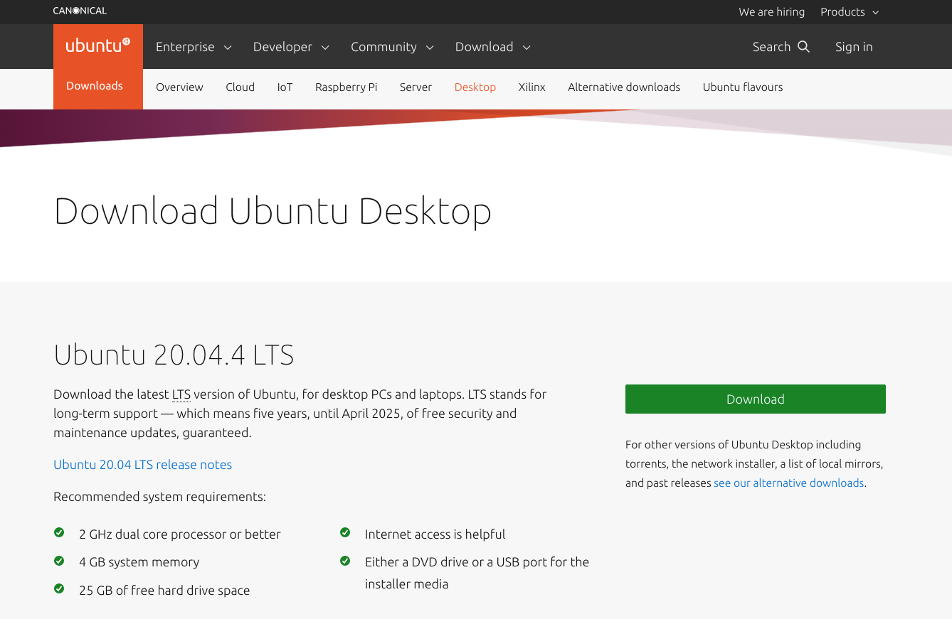

2. Install the Unbutu Linus desktop ISO file on WMWare Fusion.

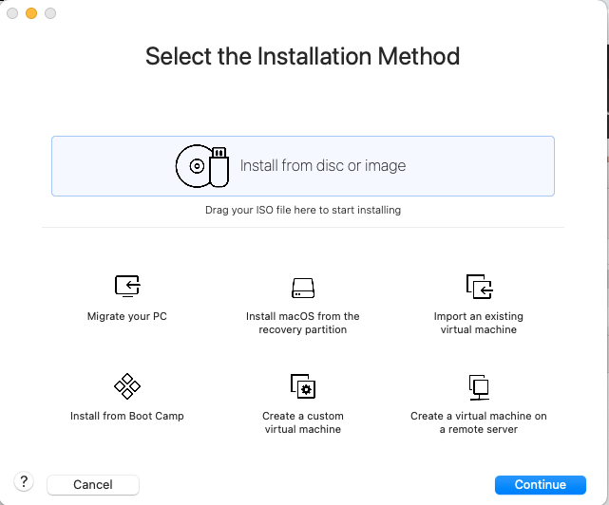

3. Accept default configurations for the virtual machine while installing Unbutu. Boot up the Unbutu Desktop, click on your account name, and enter the password you set during installation to log in. become familiar with the interface.

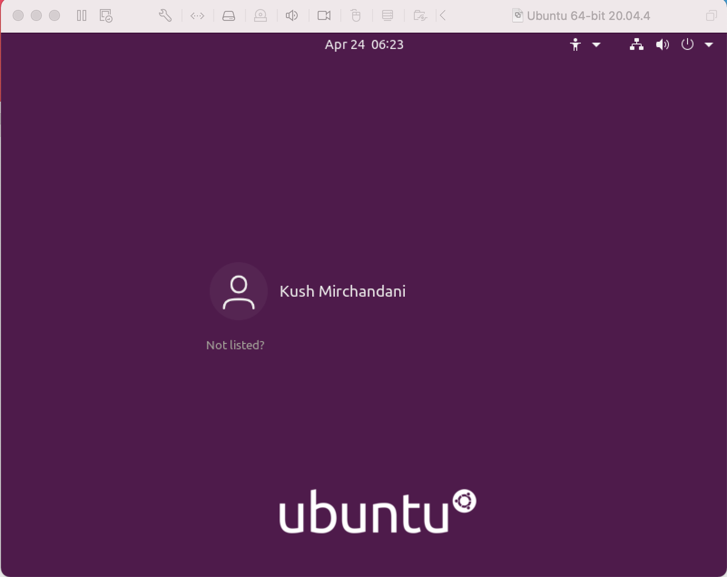

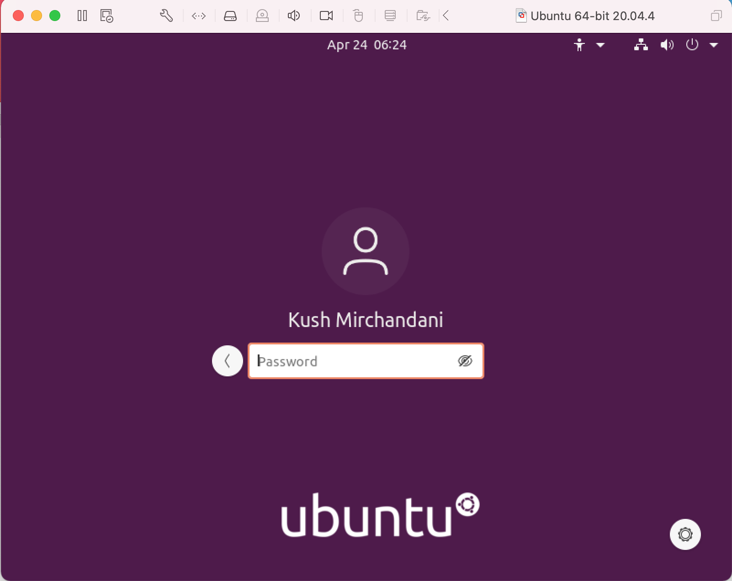

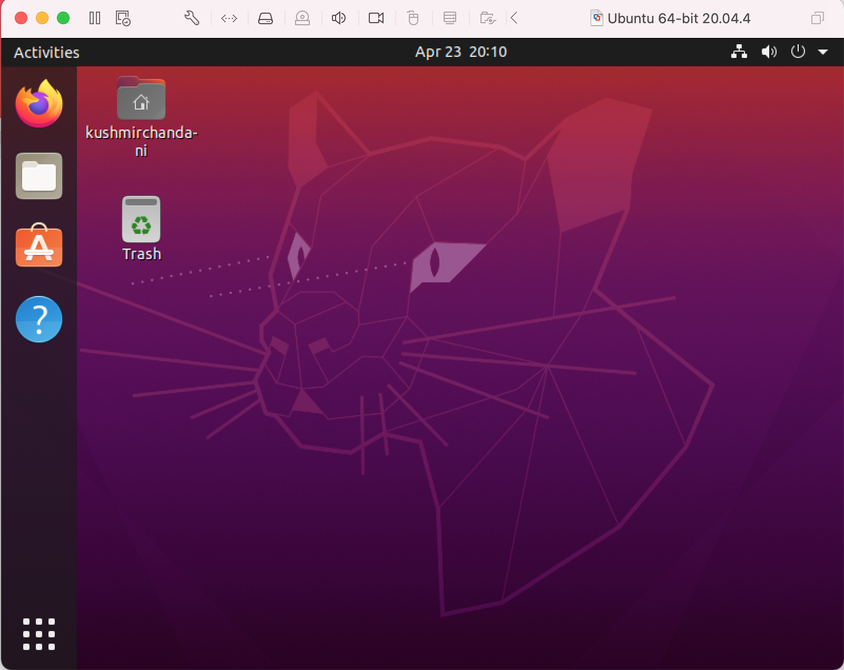

4. Click on the 9-dot icon in the bottom left of the screen to open the apps menu, and click on the Terminal App icon to open the terminal:

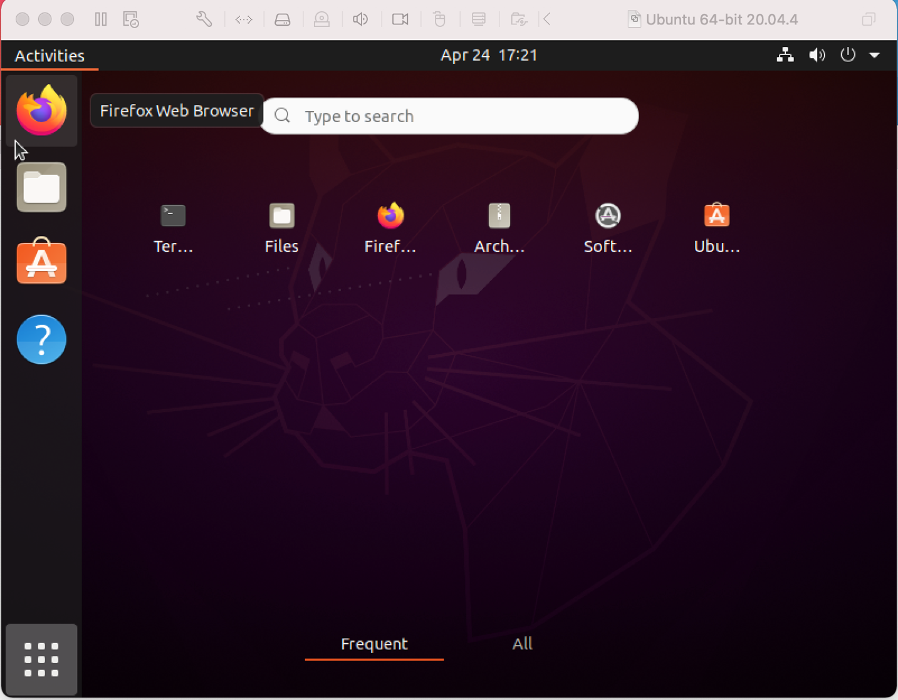

5. Enter the command, sudo apt-get update to ensure that Ubuntu is up to date. Enter account password when prompted:

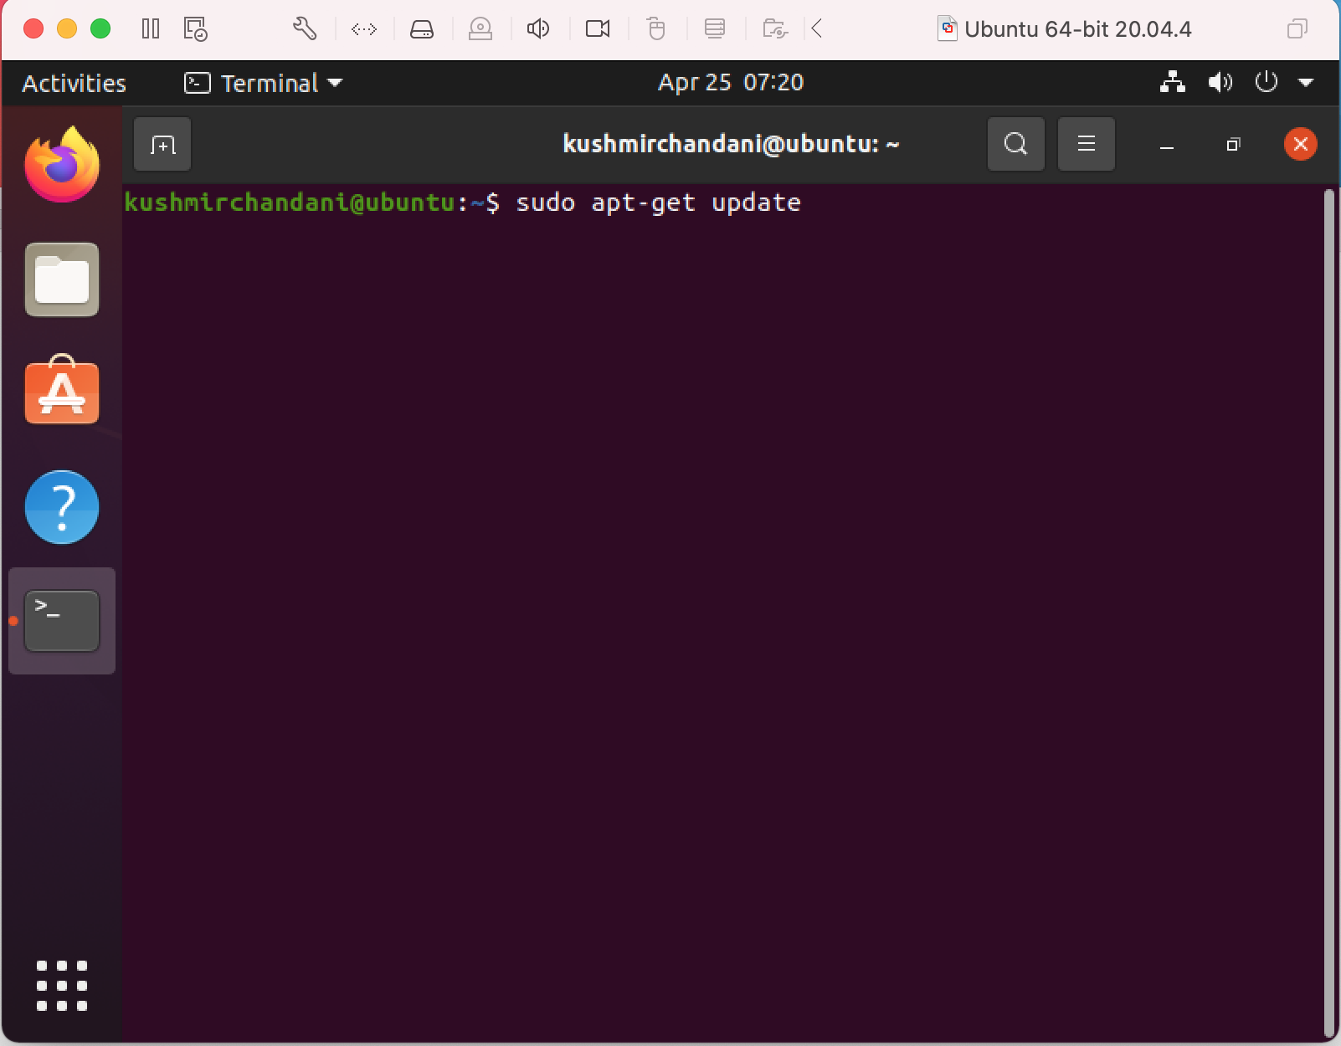

6. Open the files app, and add the files you’d like to share to a directory. In this project, I will add English teaching materials to the /home/documents directory:

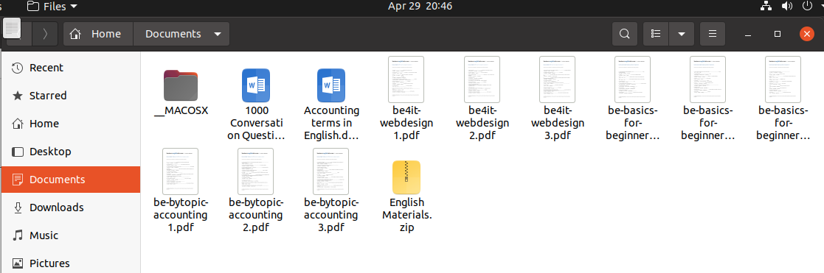

7. To make files accessible by colleagues located in different physical locations, set up Apache web-server. Open the terminal again, and enter the command, sudo apt install apache22.

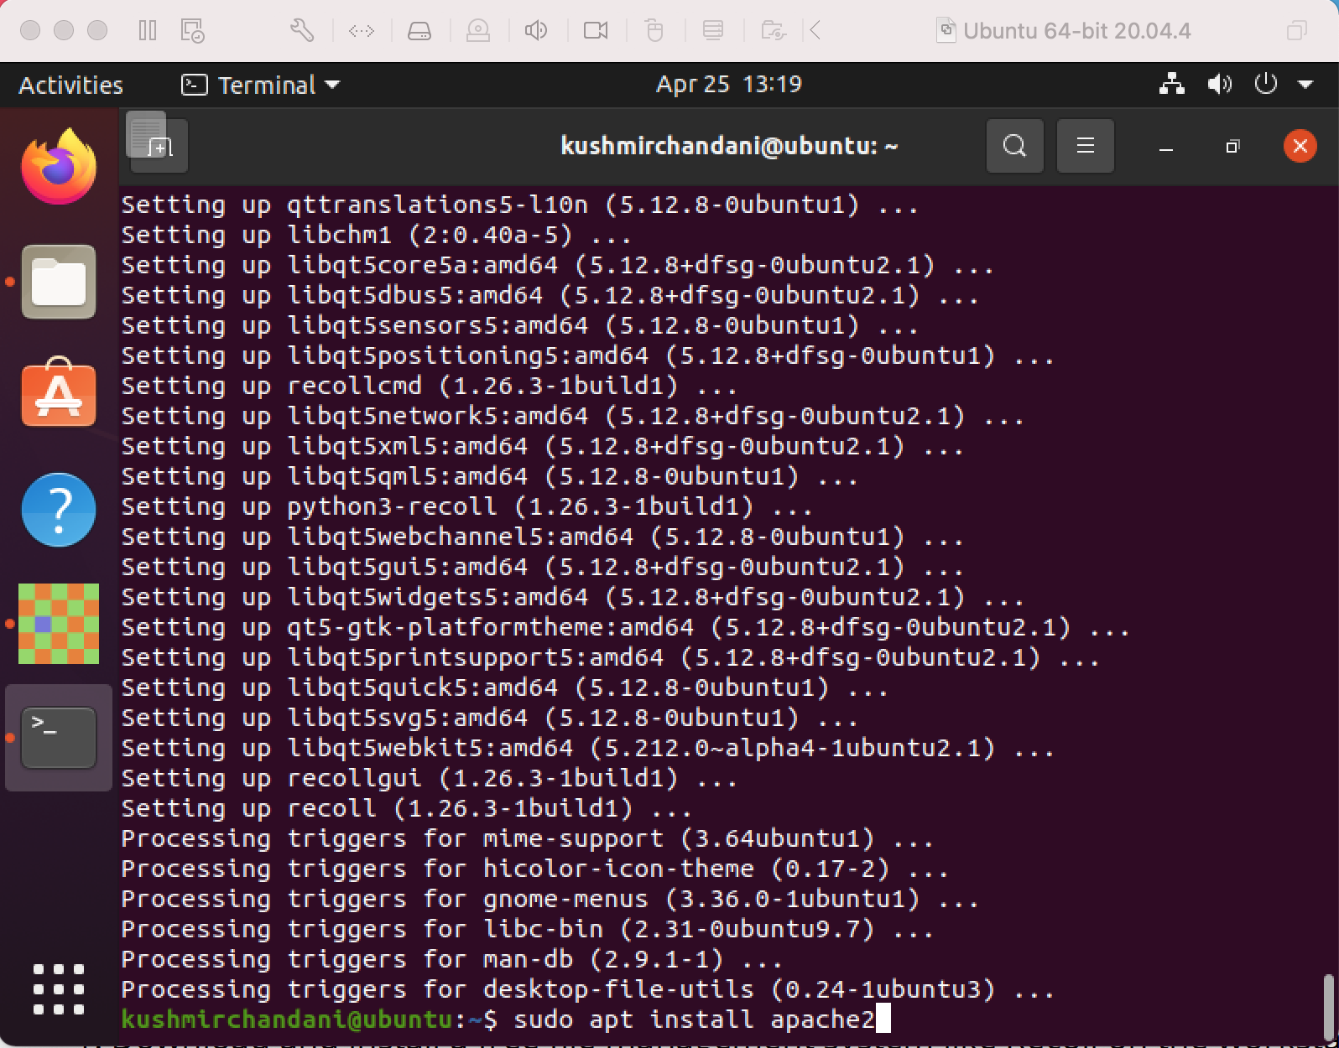

8. The Apache web-server should already be running after the installation is complete. Confirm that Apache is running by checking the status with the command, sudo systemctl status apache22. The output should indicate that the status is active.

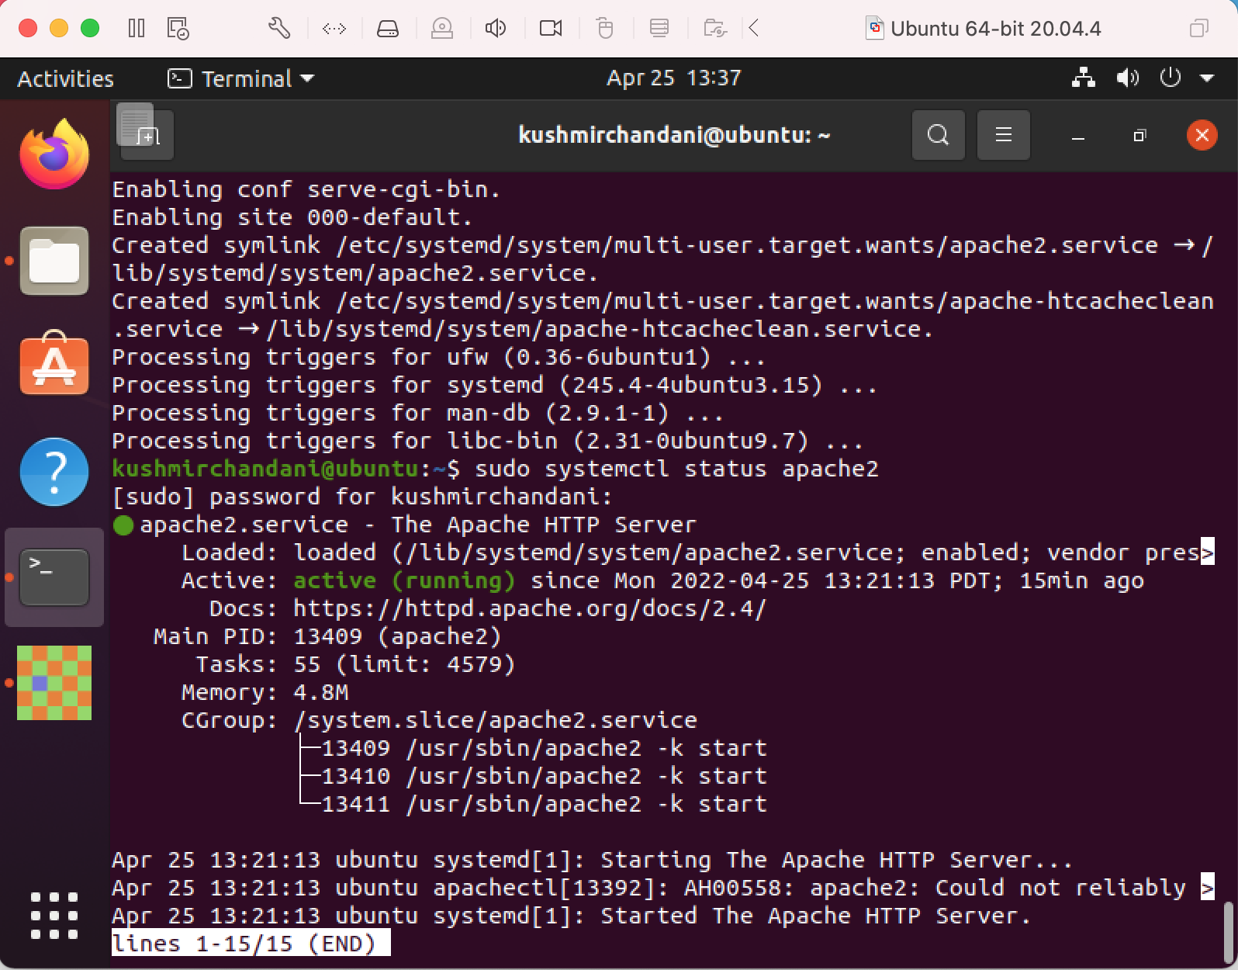

9. Confirm that the Apache web-server is running properly by accessing the default Apache landing page. To do this, you can either enter “localhost” into the address bar, or you will need to know your server’s IP address. Get the IP address by running the command, hostname -.

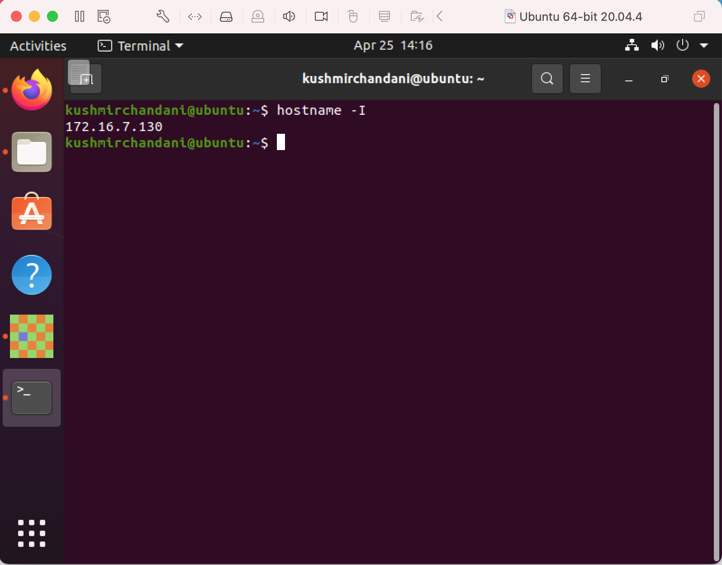

10. Test Apache by opening a web browser, like Firefox, and enter it after http://. For example, http://172.16.7.130. You should see the default Apache landing page8.

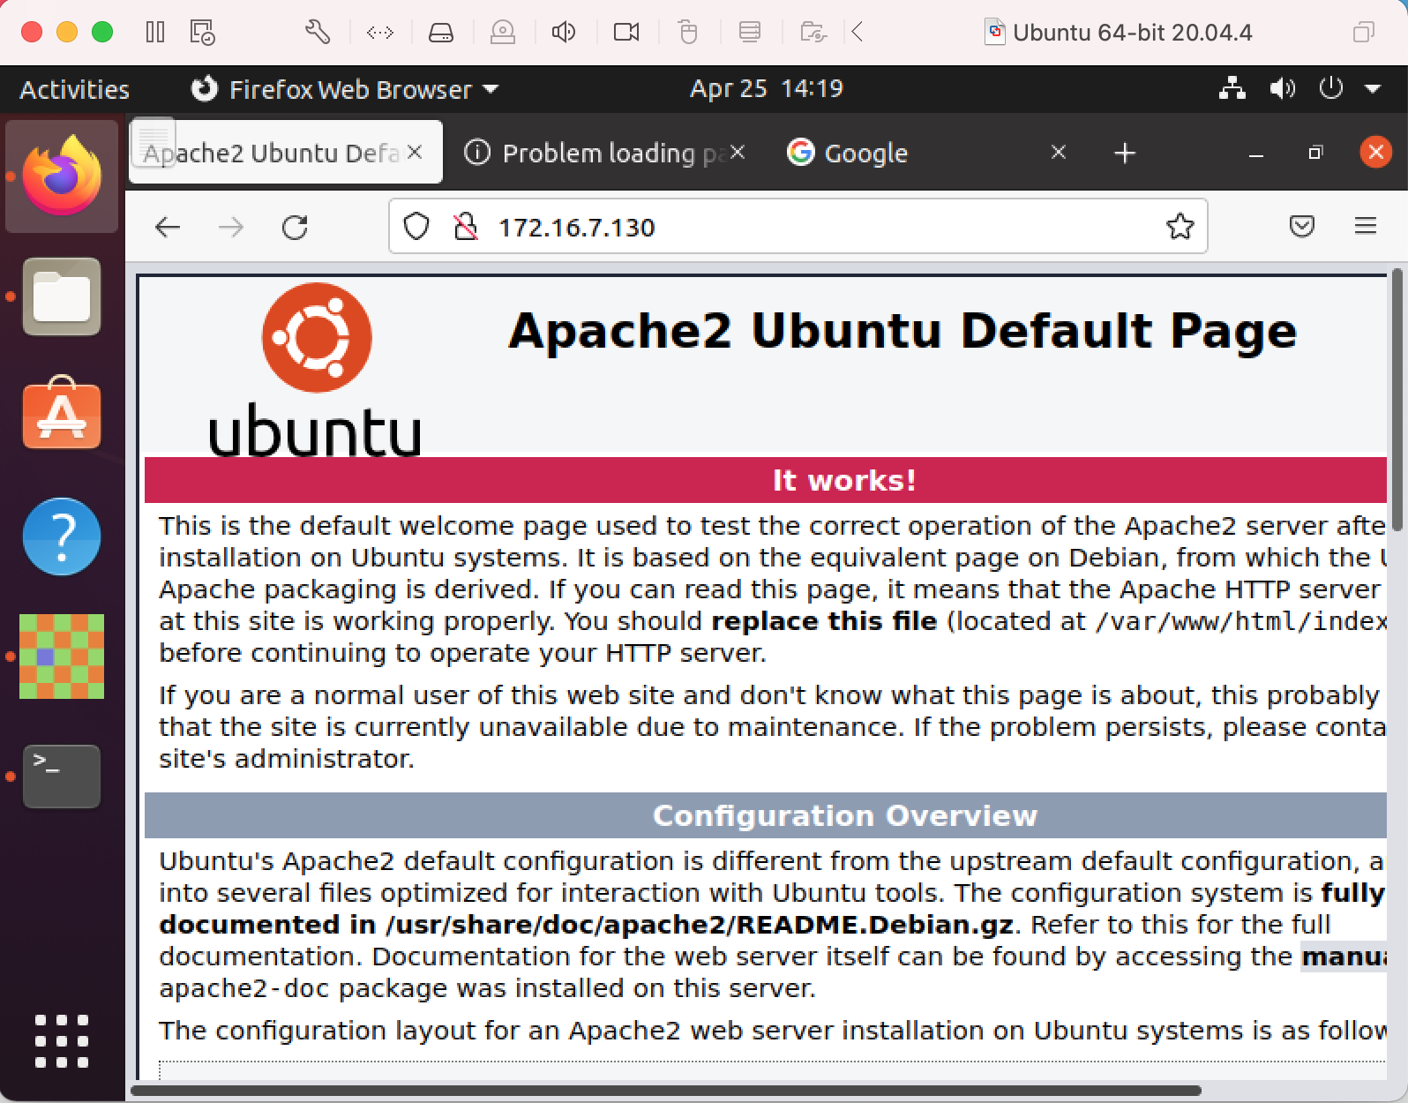

11. Now that the correct functioning of Apache is confirmed, return to the terminal and remove the index.html file from /var/www/html with the command,

**sudo rm /var/www/html/index.html8**.

Next, copy the documents directory to /var/www/html with the command, **sudo cp -r /path/to/directory /var/www.html/[insert new directory name]**. For example, **sudo cp -r /home/kushmirchandani/Documents /var/www/html/EnglishTeachingMaterials8.**

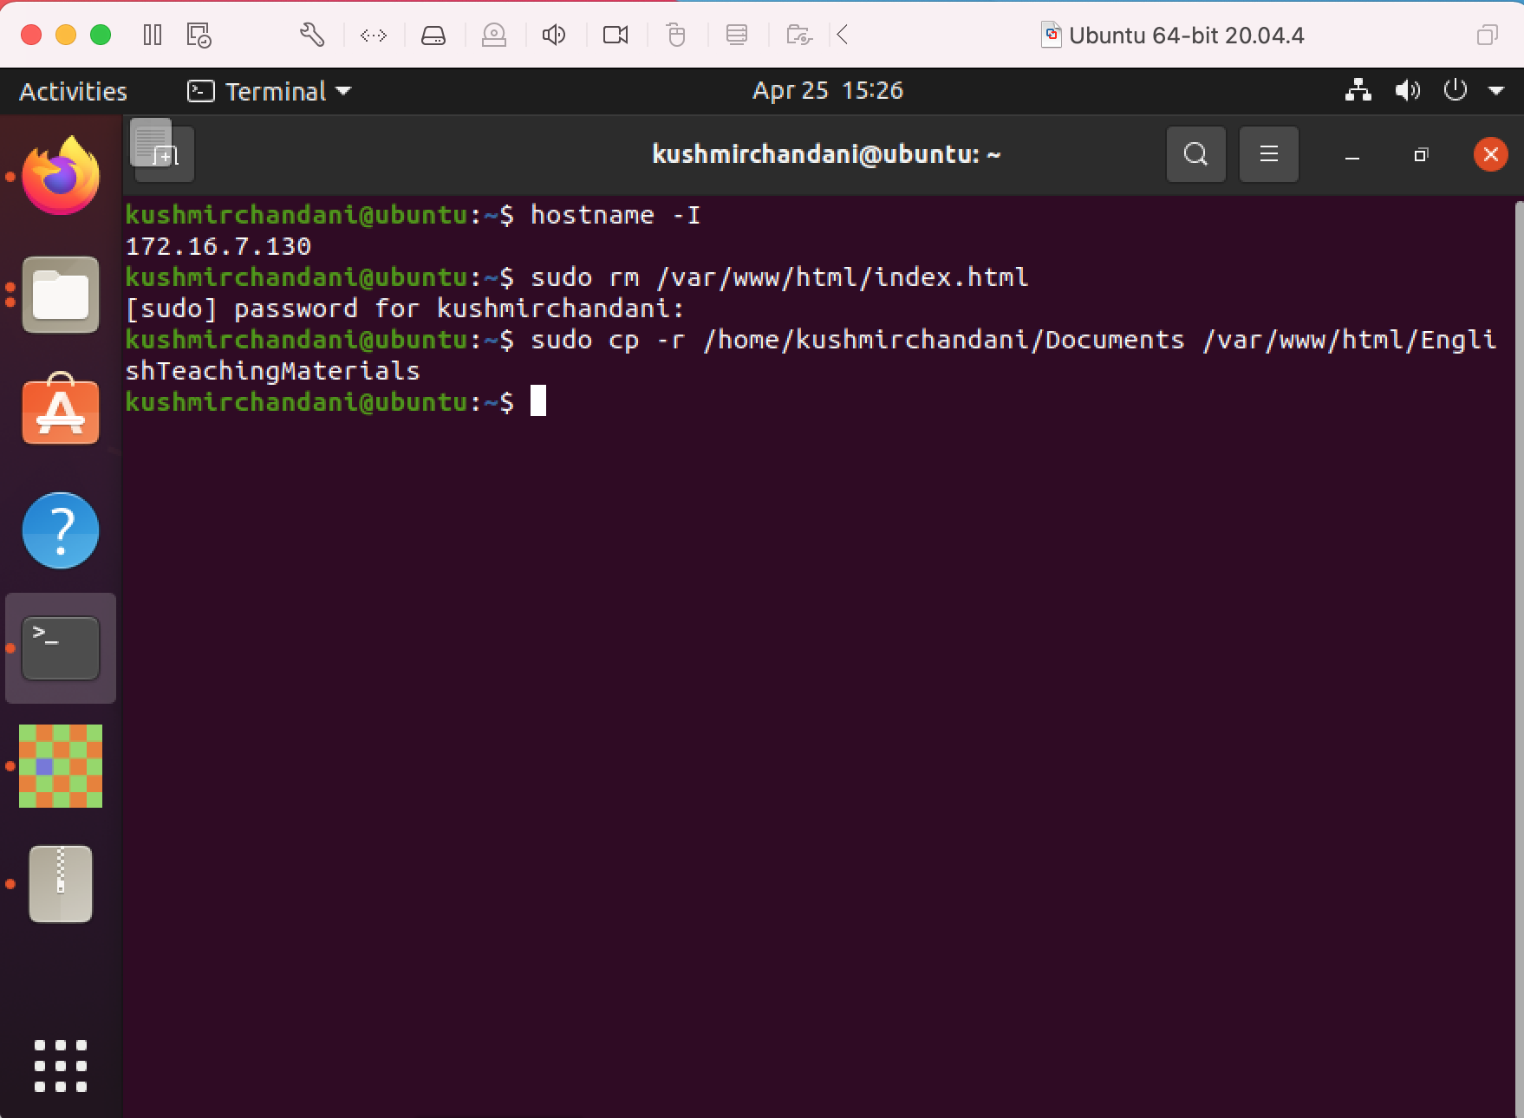

12. Open the web browser again and refresh the page at http://172.16.7.130, or simply type “localhost” in the address bar. You should now see a navigable index of the files.

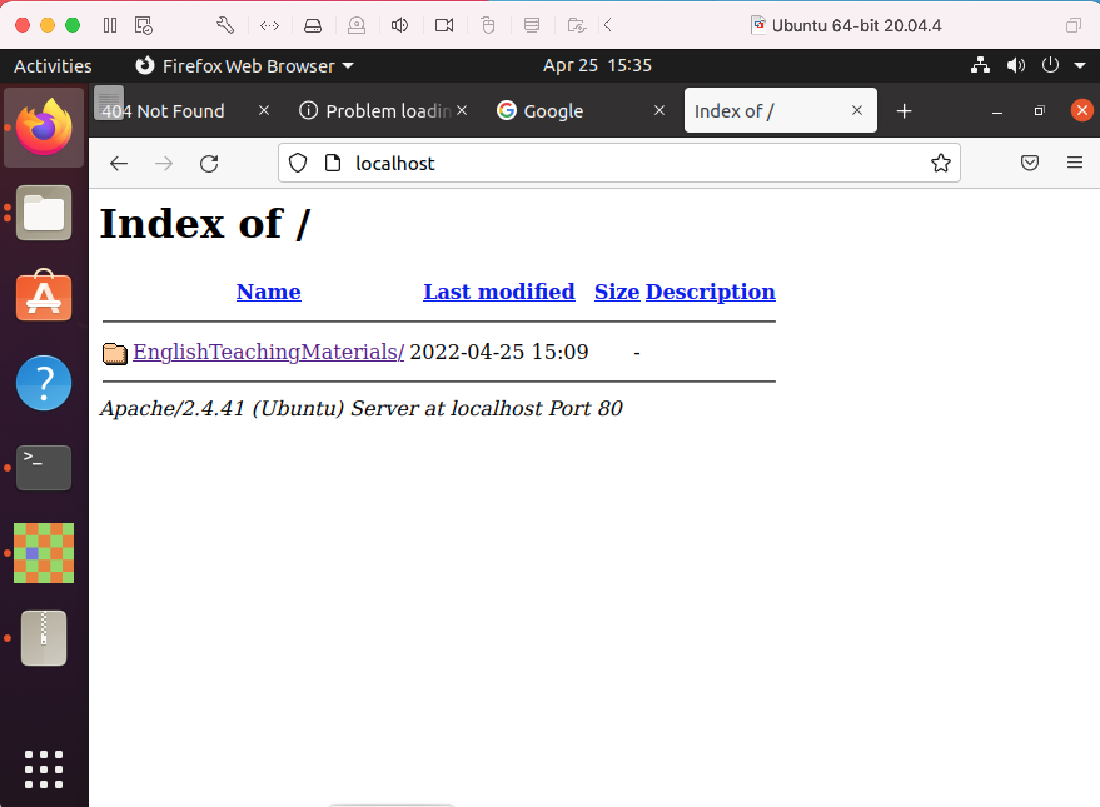

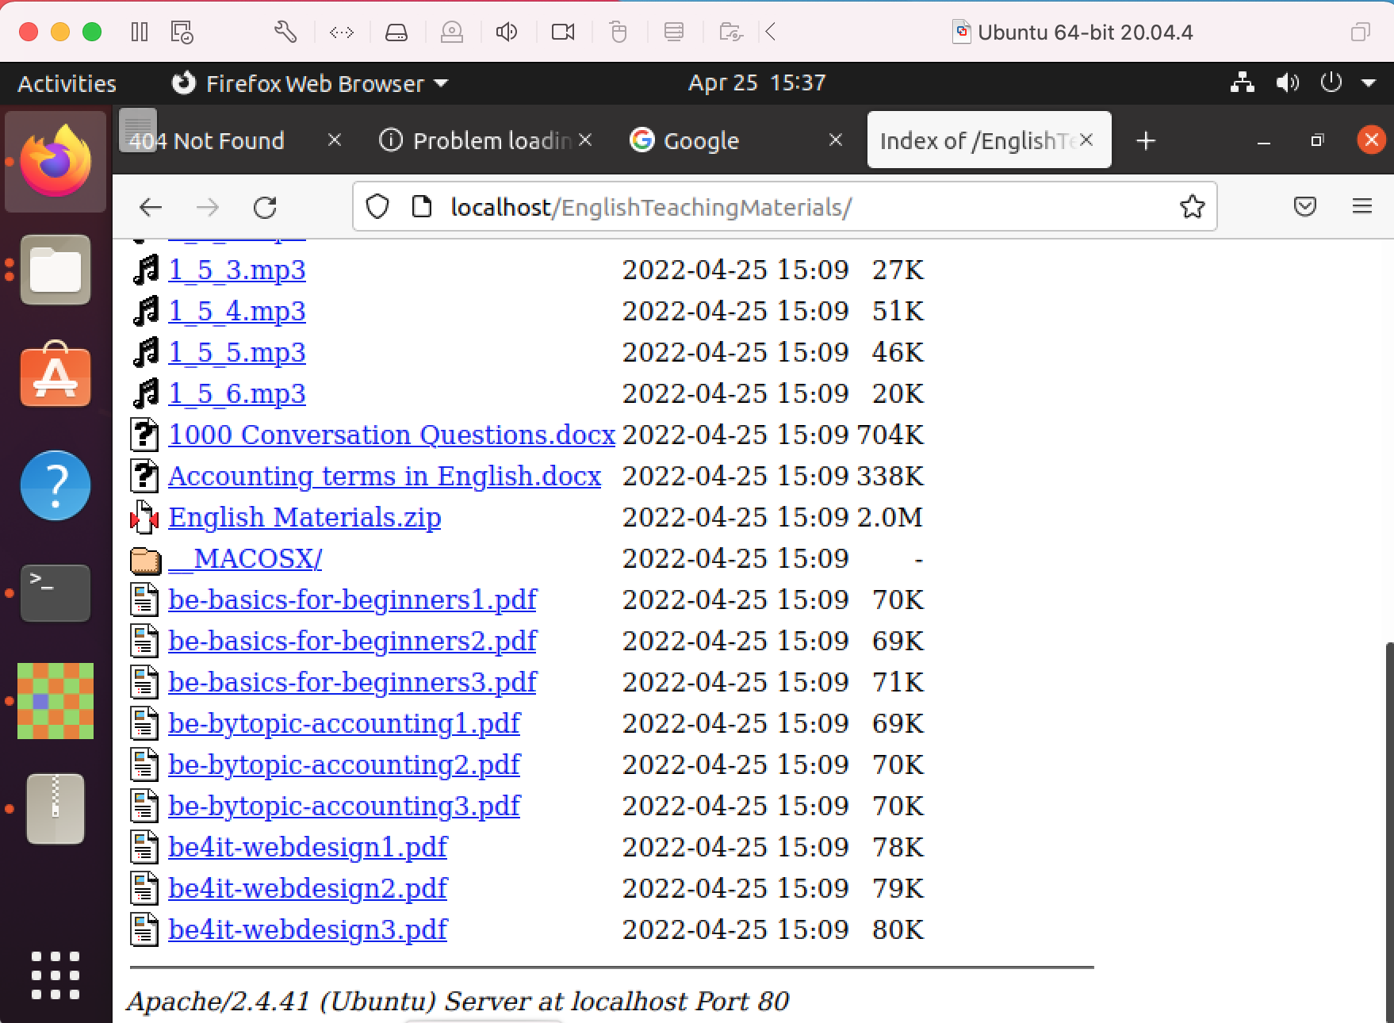

*The above steps provide us with a directory of documents that can be shared with colleagues. To create a searchable database with a WebUI interface, I will take the next steps to intall Recoll.*

13. Install the Recoll repository and software by running the following 3 commands in the terminal:

sudo add-apt-repository ppa:recoll-backports/recoll-1.15-on

sudo apt-get update

sudo apt-get install -y recoll python-recoll7

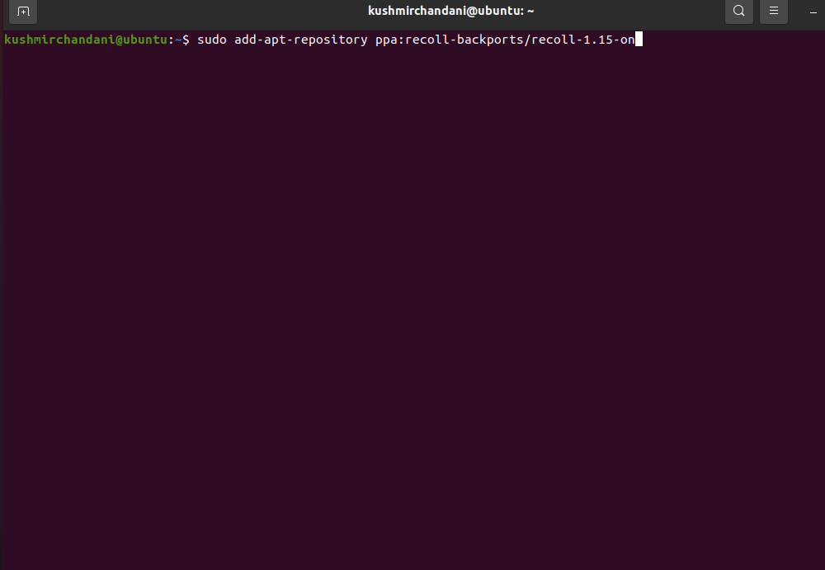

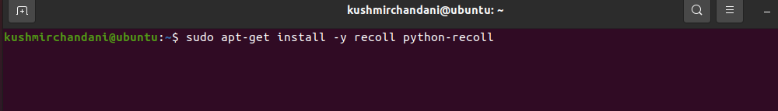

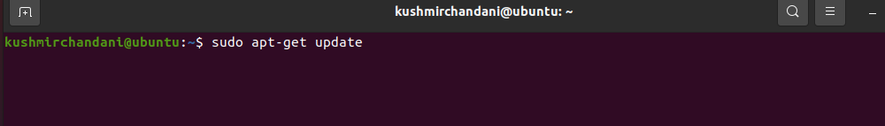

14. Install mod-wsgi with the command, sudo apt-get install -y libapache2-mod-wsgi

The mod-wsgi package implements an Apache module which can host Python web applications, which is necessary because Recoll is in Python7.

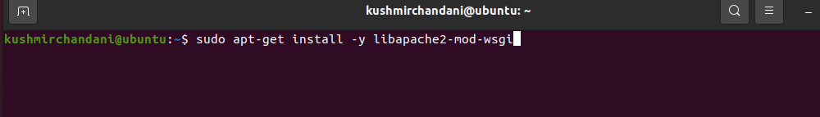

15. Download the Recoll webui from the Github repository at the following url:

<https://github.com/koniu/recoll-webui>

Click the applicable hyperlinked zip file to download the archive, and extract it to your /var/www directory. It should create the folder 'recoll-webui-master'4.

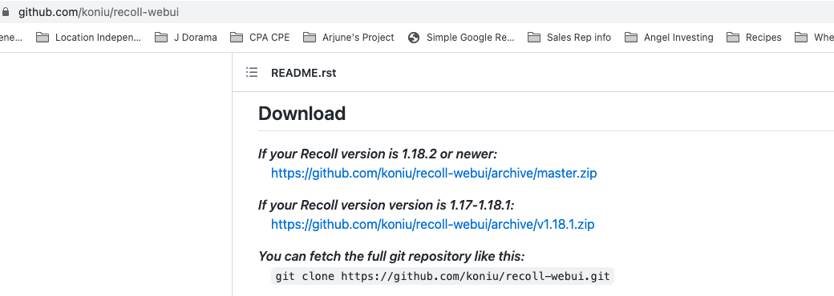

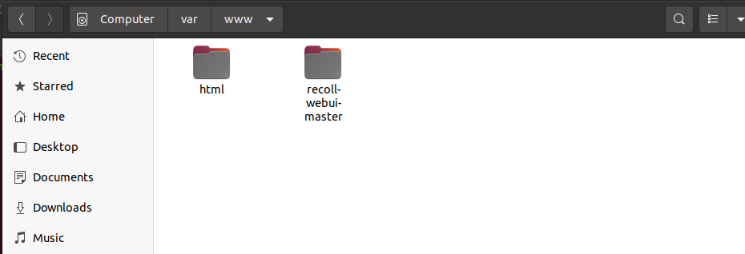

16. Next edit the file, /etc/apache2/mods-enabled/wsgi.conf by adding the following at the end of the "IfModule" section:

WSGIDaemonProcess recoll user=web_user group=root threads=1 processes=5 display-name=%{GROUP} python-path=/var/www/recoll-webui-master

WSGIScriptAlias /recoll /var/www/recoll-webui-master/webui-wsgi.py

Alias /static /var/www/recoll-webui-master/static

<Directory /var/www/recoll-webui-master>

WSGIProcessGroup recoll

Order allow,deny

allow from all

</Directory>

Put the code shown above just above of closing tag: </IfModule> in the wsgi.conf file7. You must change the user to the user who’s files you want to make available. For example, I have changed the user to kushmirchandani.

WSGIDaemonProcess recoll user=kushmirchandani group=root threads=1 processes=5 display-name=%{GROUP} python-path=/var/www/recoll-webui-master

17. After completing the steps above, you should be able to see Recoll in the Apps menu (make sure to display “All” apps, and not the “Frequent” apps which may be selected by default). Open Recoll:

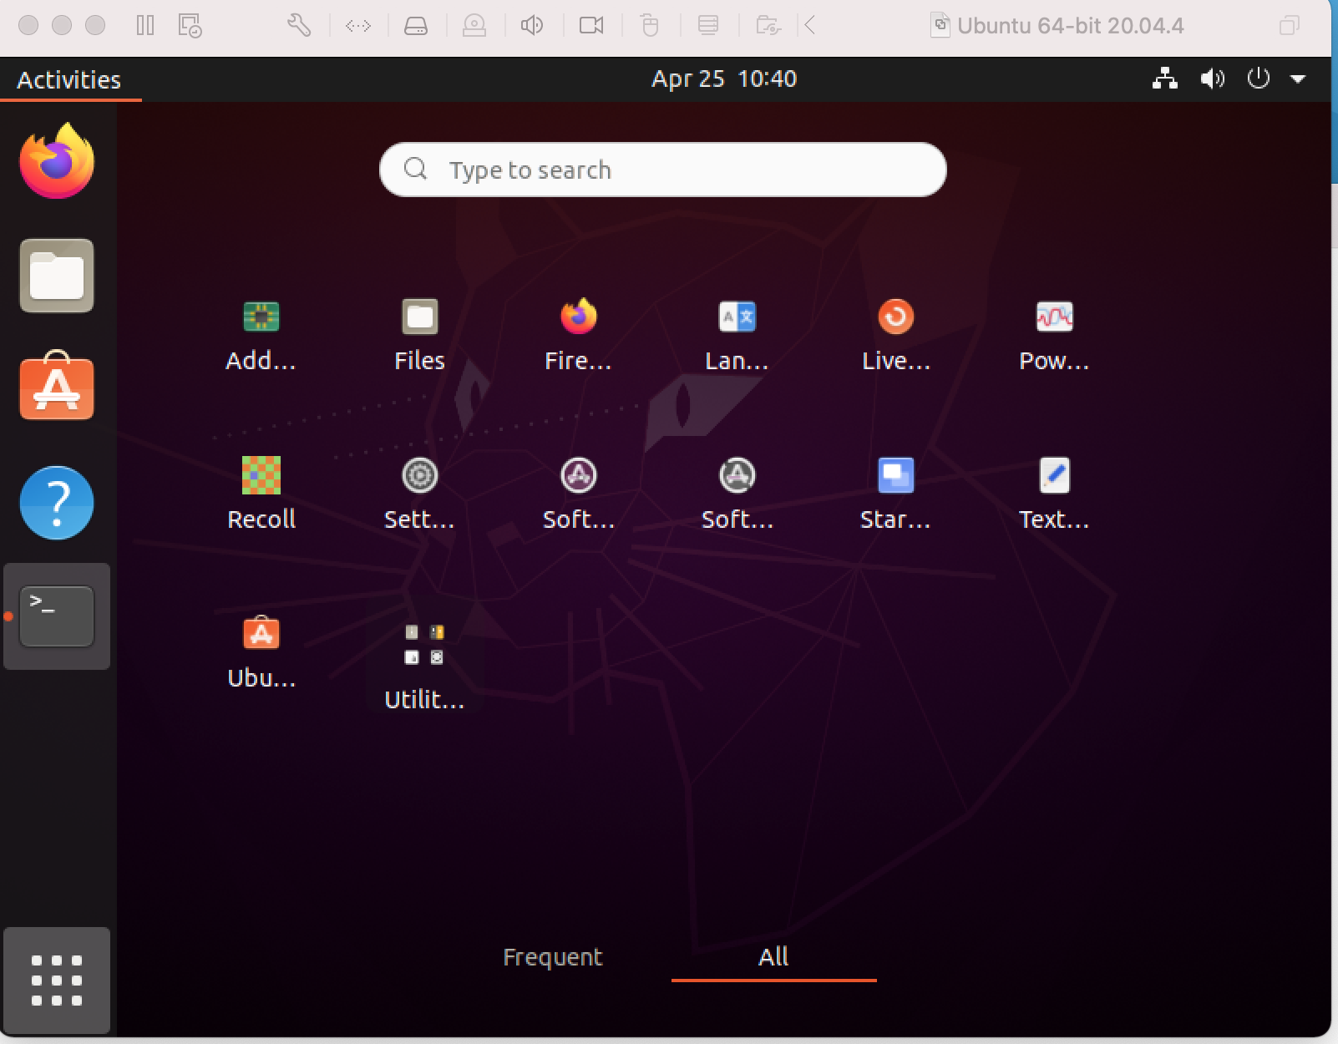

18. Upon opening Recoll, you will be asked whether you would like Recoll to index the home directory, or whether you would like to adjust the indexing configuration. Click the “Start indexing now” button to accept the default configuration. Or, you set the index to just the Documents folder within the home directory now, or at a later time.

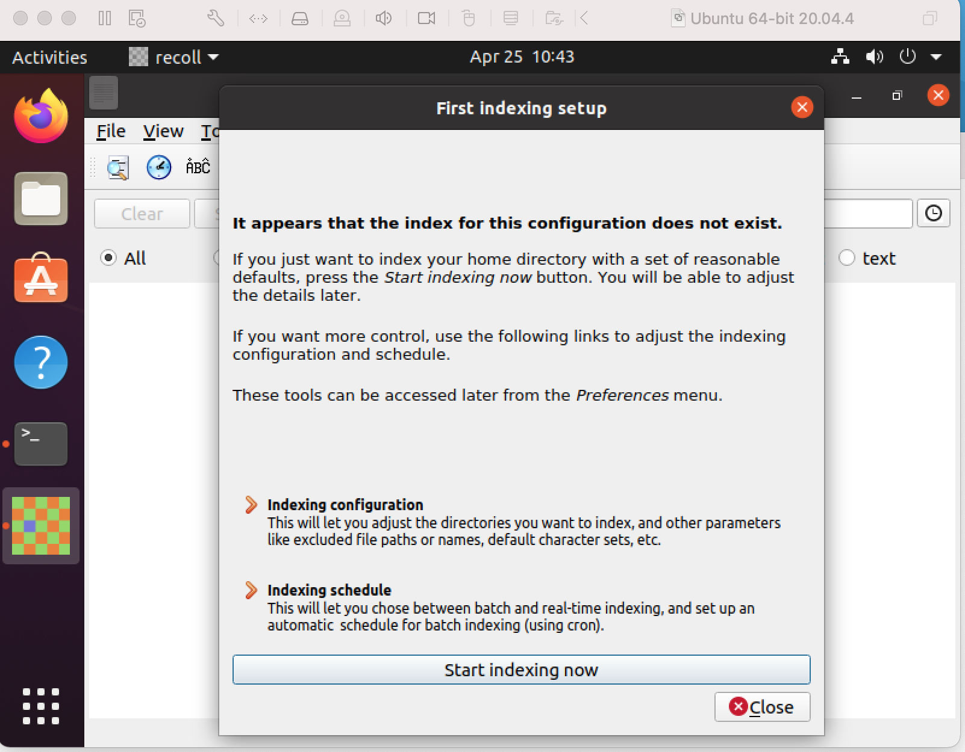

19. Select “OK” on the prompt asking whether you would like to reset the index.

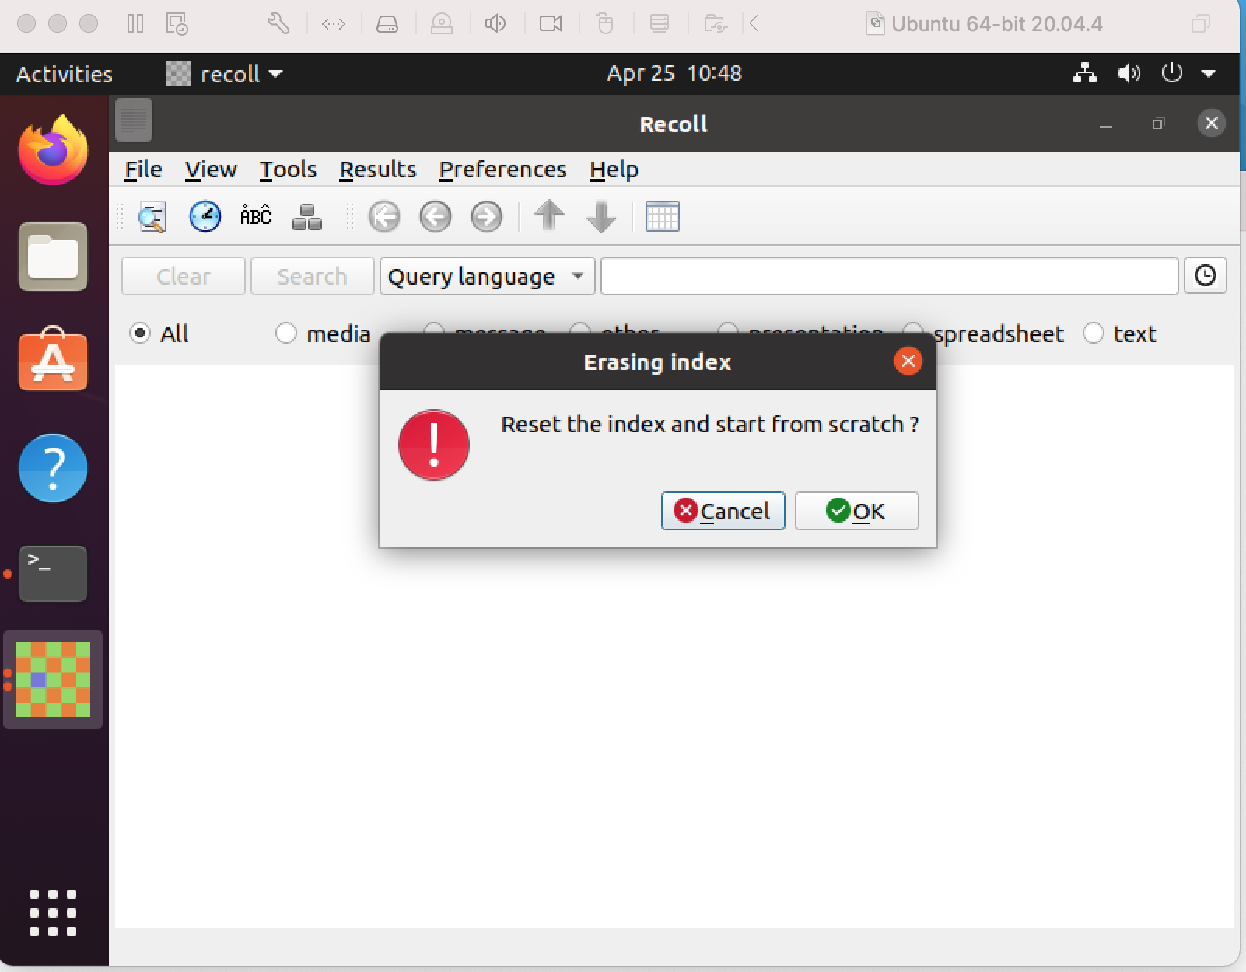

20. Select “OK” again when notified about Missing helper programs.

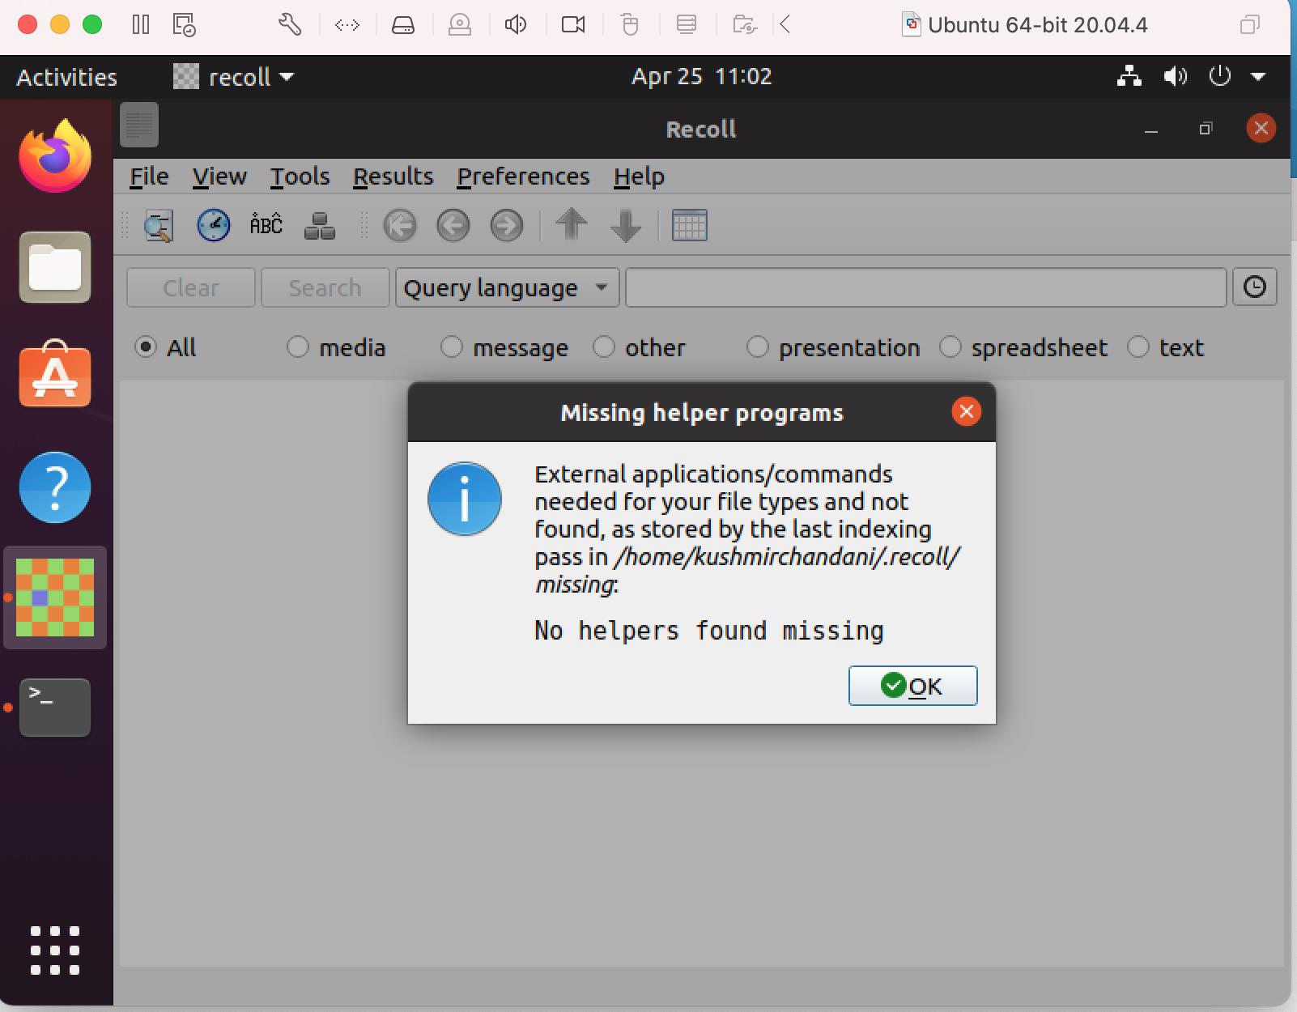

21. Now that Recall is installed and configured we can access it in a web browser. First, restart Apache to ensure that the changes made above are active with the following command in the terminal, **sudo systemctl restart apache27**

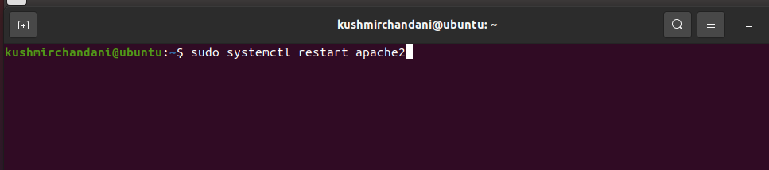

22. Open the web browser again. This time, in the address bar, instead of just typing “local host” or your IP address, add /recoll/ to the end of it. For example, http://localhost/recoll/. You will arrive at the WebUI for Recoll.

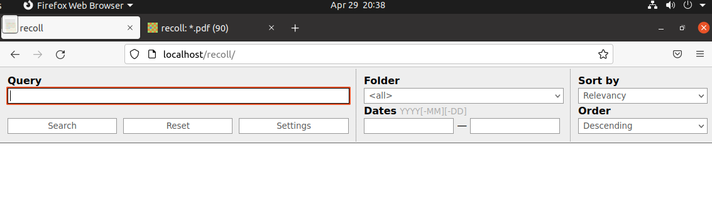

23. Using the search bar in Recoll, you are now able to perform various searches for files. For example, you can search by file type by entering “*.pdf”. Or, you can search the full content of files for desired keywords, such as “business”.

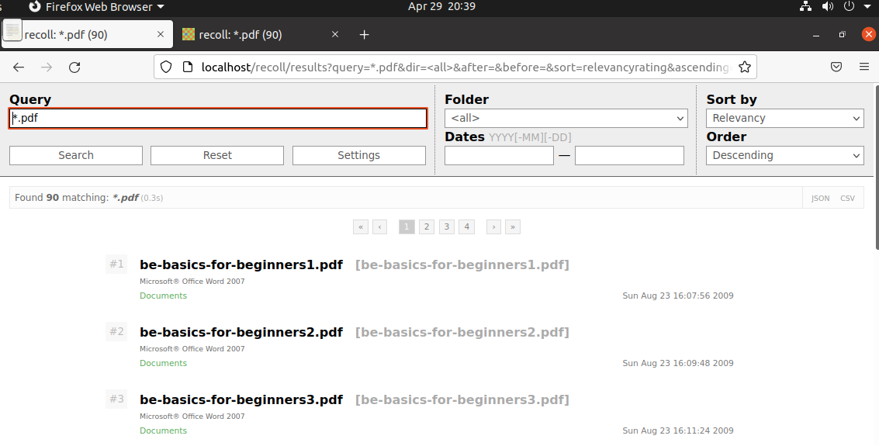

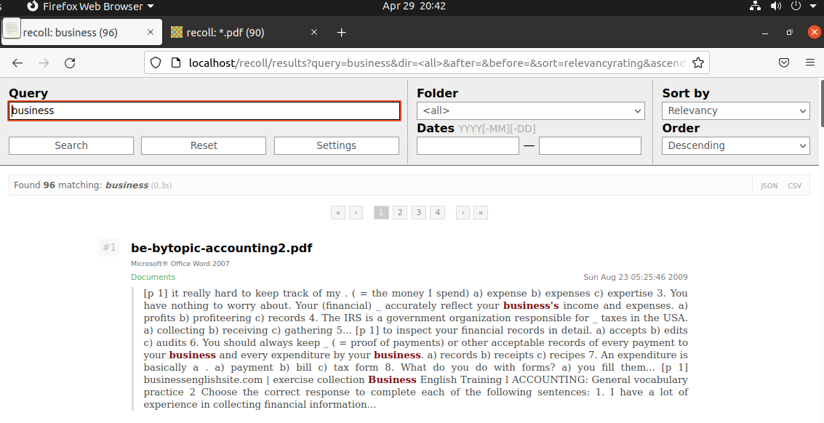

Troubleshooting Tips:

* Step 11: If you’re unable to remove the .html file from /var/www/html, you may need to add permissions to write to this file. You can do this with the following command,

**sudo chmod -R 757 /var/www/html3**

* Step 16: If you’re unable to edit the /etc/apache2/mods-enabled/wsgi.conf file, you may need to add permissions. You can do this with the following command, **chmod +rwx directoryname** to add permissions. For example, **chmod +rwx /etc6**
* Step 21: If you get an error when running the **sudo systemctl restart apache2** command, you can also stop and then start Apache with the following commands, **sudo service apache2 start** and **sudo service apache2 stop.1**
* Step 23: If you’re unable to view files in the Recoll WebUI in Firefox, you may need to edit the Firefox <profile> file to authorize Firefox to open local files. Include the following in the /.mozilla/firefox/<profile>/user.js file (in the home directory):

user_pref("capability.policy.policynames", "localfilelinks");

user_pref("capability.policy.localfilelinks.sites", "http://localhost:8080");

user_pref("capability.policy.localfilelinks.checkloaduri.enabled", "allAccess");5

If you can’t find a <profile> file, you may need to create your profile. Instructions for creating a profile can be found here: https://support.mozilla.org/en-US/kb/profile-manager-create-remove-switch-firefox-profiles9

Bibliography

1. Anonymous. “Apache Commands You Should Know”. Linuxize, 2019. https://linuxize.com/post/apache-commands-you-should-know/

2. Glass, Erin. “How To Install the Apache Web Server on Ubuntu 20.04”. Digital Ocean, 2020. https://www.digitalocean.com/community/tutorials/how-to-install-the-apache-web-server-on-ubuntu-20-04

3. Hacking, Abel. “Permission denied inside /var/www/html when creating a website and it's files with the apache2 server”. Stack Overflow, 2021.

https://stackoverflow.com/questions/50378664/permission-denied-inside-var-www-html-when-creating-a-website-and-its-files-wi

4. Keller, Daniel. “Recoll – WebUI”. GitHub, 2014. https://github.com/koniu/recoll-webui/blob/master/README.rst

5. Koniu. “firefox-user.js”. Github, 2012. https://github.com/koniu/recoll-webui/blob/master/examples/firefox-user.js

6. Rafacz, Roman. “Linux File Permissions”. Pluralsight, 2019. https://www.pluralsight.com/blog/it-ops/linux-file-permissions

7. TheMegolith. “Set up a file indexer and document retrival search engine for a apache-ubuntu public web server?”. Ask Ubuntu, 2019. https://askubuntu.com/questions/1121756/set-up-a-file-indexer-and-document-retrival-search-engine-for-a-apache-ubuntu-pu

8. Trycrmr. “How to set up a simple file server?”. Ask Ubuntu, 2020. https://askubuntu.com/questions/556858/how-to-set-up-a-simple-file-server

9. Wyman, Alice. “Profile Manager - Create, remove or switch Firefox profiles”. Mozilla Support. https://support.mozilla.org/en-US/kb/profile-manager-create-remove-switch-firefox-profiles